CS375 Assignment 5
Part A: Due on November 14 (by 11:59pm)

Objective:
- Enhance the concept of greedy algorithms
- Design program for greedy algorithm implementation.

Part A:

- [7%] Find the minimum spanning tree using the Prim’s algorithm for the following graph starting at node A. Show the order that the nodes are added into the minimum spanning tree. Draw the minimum spanning tree and indicate the weight summation of the MST.

A
B
C
E
F
G
H
2
5
1
1
4
3
4
3
2
2
D
4
3
2
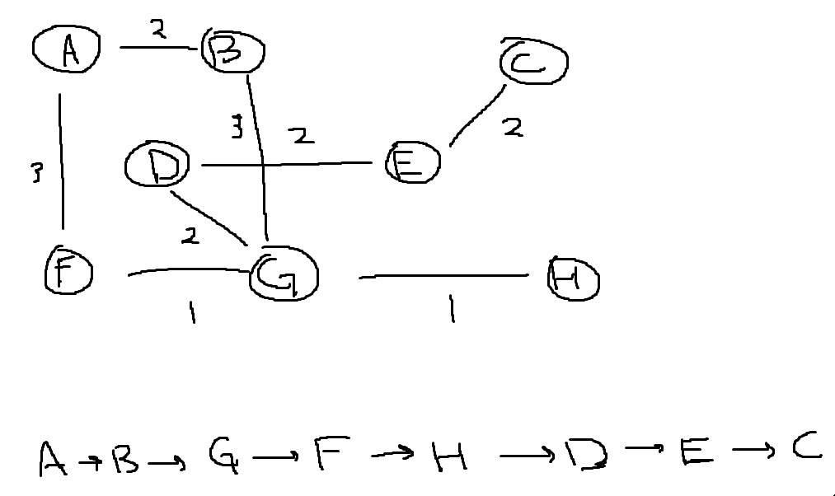
Answer:

- (7%) Suppose that we have an international conference, and need to schedule a series of sessions among a number of hotel conference rooms. We wish to schedule all the sessions using as few rooms as possible for saving budget. For example: we need to schedule following sessions:
Session 1 (Education): at 9:30 - 10:30am
Session 2 (Economics): at 9:30 – 10:30am
Session 3 (Security): at 1:30 – 2:30pm
Session 4 (Med-Care): at 12:00 –1:00pm
Session 5 (Insurance): at 10:30 – 11:30am
Session 6 (Science): at 11:30am – 12:30pm
Section 7 (Technology): at 11:30am - 12:30pm
Session 8 (Transportation): at 1:00 – 2:00pm

Give an efficient greedy algorithm to determine how many conference rooms are needed. Show your solution using active selection strategy. What is the time complexity if k rooms are needed.
Answer: The greedy algorithm sorts the sessions based on their start times. For each session, if the current session can fit in a room without conflicting any ongoing session in that room, then assign it to that room. If no available room is found, then create a new one for it.
Session 1: Education (9:30 - 10:30am)
Session 2: Economics (9:30 - 10:30am)
Session 5: Insurance (10:30 - 11:30am)
Session 6: Science (11:30am - 12:30pm)
Session 7: Technology (11:30am - 12:30pm)
Session 4: Med-Care (12:00pm - 1:00pm)
Session 8: Transportation (1:00 - 2:00pm)
Session 3: Security (1:30 - 2:30pm)

Solution
Room 1: Education -> Insurance -> Science -> Transportation
Room 2: Economics -> Technology -> Security
Room 3: Med-Care
So 3 rooms are needed. The time complexity is O(nlogn).
Rooms(sort) {
Temp = 0
For I in range(2n) {
If(order[i][1] = 0) {
Temp = temp + 1
Rooms = max(rooms, temp)
}
Else {
If(temp) temp = temp – 1
}
Return rooms
}
- (7%) Show a counter example that if we remove the 5 cent coin from American money (25, 10, and 1 remain) the greedy algorithm for coin change does not guarantee a minimal number of coins.
Answer:
Suppose we want to make change for 30 cents. Using the greedy algorithm, we would first select the largest coin that is less than or equal to the target amount, which is the 25 cent coin. After selecting the 25 cent coin, we are left with 5 cents. Since we have removed the 5 cent coin from our denominations, we must now use five 1 cent coins to make up the remaining 5 cents. In total, the greedy algorithm produces 1 (25 cent coin) + 5 (1 cent coins) = 6 coins. However, the optimal solution in this case is to use three 10 cent coins to make up the 30 cents, which only requires 3 coins. Therefore, the greedy algorithm does not guarantee a minimal number of coins when the 5 cent coin is removed from the American coin system.

- [7%] Explain that if there is one edge with a weight smaller than all the other edges, that edge will be part of every minimum spanning tree.
Answer: One of the techniques of converting a graph into minimum spanning tree is by using Kruskal’s Algorithm. In Kruskal’s Algorithm the edges are first sorted according to their weights in ascending order. After the edges are sorted, the first edge is picked and added to the tree. The first edge has the smallest weight among all other edges. If an edge with a weight smaller than all the other edges is added to the graph after sorting the edges according to their weight, that edge will always be picked first. Hence, we can say that all the possible minimum spanning trees of the graph will always include that new edge.

- [7%] Explain whether it is always, never, or sometimes true that the order in which the nodes are added to the MST by the Prim algorithm is the same as the order in which they encountered in the breadth-first search.

Answer: The order in which the nodes are added to the MST by the Prim algorithm is sometimes the same as the order in which they are encountered in the BFS. In Prim’s algorithm, the shortest edge is chosen from the starting node. In BFS, the priority is the best distance from the origin whereas in Prim’s algorithm, the priority is the distance from already-explored nodes no matter which connecting edge is chosen. In both algorithms, a smaller value is better.

- (1) (7%) Suppose there are a group of cities, which are modeled by a strongly connected undirected graph G = (V, E) with positive edge weights representing the distances between two cities. A particular city is the capital city a ∈ V. Give an efficient algorithm for finding shortest paths between all pairs of cities, with the one restriction that these paths must all pass through the capital city. (Note that: we allow one city to be passed more than once if needed).
Answer:
Use Dijkstra’s method of finding the shortest path between all pairs of cities.
citiesPaths() {
for all u ∈ V {
dist[u] = inf
prev[u] = null
dist[s] = 0
}
H = makequeue(V)
While(H is not empty) u = deletemin(H)
For all edges(u, v) ∈ E {
If dist[v] > dist[u] + L[u, v] {
Dist[v] = dist[u] + L[u, v]
Prev[v] = u
}
}
Decreasekey(H, v)
}

(2) (8%) Programming: Implement your designed algorithm, and print out the shortest path from node d to node i via node a using the graph shown below. Suppose the capital city is node “a”.

5
21
18
3
2
4
7
16
g
h
b
a
c
d
e
f
14
9
6
113
1222
i
j
k
8
19
1
15
17
10
13
20

Answer:
The shortest path from node d to node I via node a is 40(70+6+12+15).

- (7%) Suppose the Dijkstra’s algorithm runs on the following graph, starting at node A. (a) Draw a table showing the intermediate distance values of all the nodes at each iteration of the algorithm. (b) Show the final shortest-path tree.
A
B
C
D
E
F
G
H
1
2
1
5
1
1
4
4
2
6
8
6
1
Answer:
a)
1)
 | A | B | C | D | E | F | G | H
0 | 0 | Inf | Inf | Inf | Inf | Inf | Inf | Inf

2)
 | A | B | C | D | E | F | G | H
0 | 0 | Inf | Inf | Inf | Inf | Inf | Inf | Inf
1 | 0 | 1 | Inf | Inf | 4 | 8 | Inf | inf

3)
 | A | B | C | D | E | F | G | H
0 | 0 | Inf | Inf | Inf | Inf | Inf | Inf | Inf
1 | 0 | 1 | Inf | Inf | 4 | 8 | Inf | inf
2 | 0 | 1 | 3 | Inf | Inf | 7 | 7 | Inf

4)
 | A | B | C | D | E | F | G | H
0 | 0 | Inf | Inf | Inf | Inf | Inf | Inf | Inf
1 | 0 | 1 | Inf | Inf | 4 | 8 | Inf | inf
2 | 0 | 1 | 3 | Inf | Inf | 7 | 7 | Inf
3 | 0 | 1 | 3 | 4 | 4 | 7 | 5 | Inf

5)
 | A | B | C | D | E | F | G | H
0 | 0 | Inf | Inf | Inf | Inf | Inf | Inf | Inf
1 | 0 | 1 | Inf | Inf | 4 | 8 | Inf | inf
2 | 0 | 1 | 3 | Inf | Inf | 7 | 7 | Inf
3 | 0 | 1 | 3 | 4 | 4 | 7 | 5 | Inf
4 | 0 | 1 | 3 | 4 | 4 | 7 | 5 | 8

6)
 | A | B | C | D | E | F | G | H
0 | 0 | Inf | Inf | Inf | Inf | Inf | Inf | Inf
1 | 0 | 1 | Inf | Inf | 4 | 8 | Inf | inf
2 | 0 | 1 | 3 | Inf | Inf | 7 | 7 | Inf
3 | 0 | 1 | 3 | 4 | 4 | 7 | 5 | Inf
4 | 0 | 1 | 3 | 4 | 4 | 7 | 5 | 8
5 | 0 | 1 | 3 | 4 | 4 | 7 | 5 | 8

7)
 | A | B | C | D | E | F | G | H
0 | 0 | Inf | Inf | Inf | Inf | Inf | Inf | Inf
1 | 0 | 1 | Inf | Inf | 4 | 8 | Inf | inf
2 | 0 | 1 | 3 | Inf | Inf | 7 | 7 | Inf
3 | 0 | 1 | 3 | 4 | 4 | 7 | 5 | Inf
4 | 0 | 1 | 3 | 4 | 4 | 7 | 5 | 8
5 | 0 | 1 | 3 | 4 | 4 | 7 | 5 | 8
6 | 0 | 1 | 3 | 4 | 4 | 6 | 5 | 6

b) 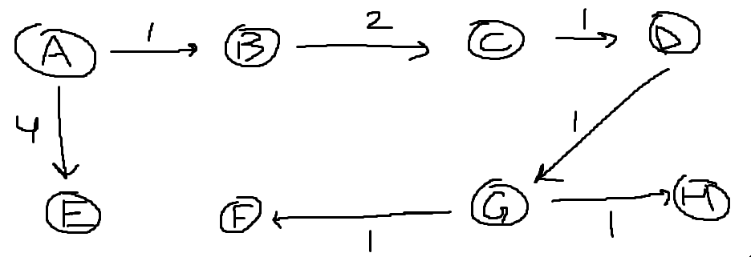
- [7%] To construct a road network, we need to plan a minimum cost. Using Kruskal’s algorithm to find your solution. Show the intermediate step and the final MST. Indicate the total length of the road network.
A
B
C
E
F
G
H
1
4
5
1
2
2
2
3
D
4
5
2
Answer:
Edge | Weight | Selection
AB | 1 | Yes
CH | 1 | Yes
AF | 2 | Yes
DG | 2 | Yes
EG | 2 | Yes
BE | 2 | Yes
DE | 3 | No
FG | 4 | No
EC | 4 | Yes (ends here)
AD | 5 | No
GH | 5 | No

DE not selected because it forms a cycle. EC chosen over FG because EC is the last edge to be chosen that makes MST connected.
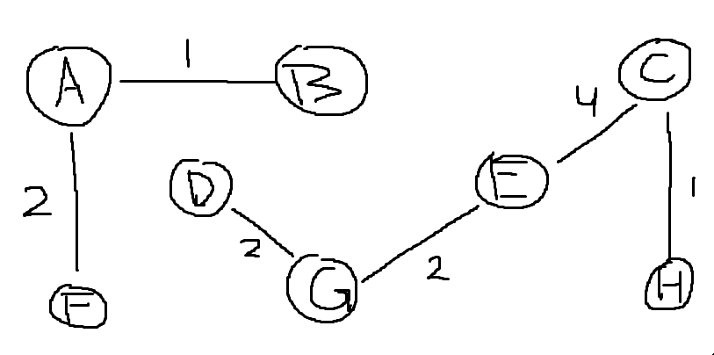
Total length = 14.
- (8%) You are downloading n files (songs, programs) from the web to a minimum number of CDs. Each CD can store exactly B bytes. More than one file can be stored on each CD, but a single file cannot be stored on more than one CD ( no split). Each file i has a size s_{i} bytes (s_{i} ≤B). Describe a greedy algorithm to solve this problem. It may not get optimal solution, If so, give a counter example.
Answer: Store files in minimum number of CDs through greedy algorithm.

diskStorage {
Take array A[] to store all the files
Sort A[] in descending order
A[] = {1, 2, 3, …, n files}
CD1 <- A[1]
For(A[2] to A[n]) {
If(any file can be made available with size equal to the left size in CD1) store A[1] in CD1
Else {
Create CD2
A[2] <- CD2
}
}
Return # of CDs used (CDn).
}

10. (7%) The notion of a minimum spanning tree is applicable to a connected weighted graph. Do we have to check a graph’s connectivity before applying Prim’s algorithm or can the algorithm do it by itself? Explain your answer.
Answer: Prim’s algorithm can check the graph’s connectivity by itself. If the algorithm reaches the entire graph’s vertices, then the graph is connected. Otherwise, the graph is disconnected as there will be no path from one sub-graph to reach to another sub-graph. Therefore, there will be some nodes left to be traversed.

- (7%) Design an algorithm for finding a maximum spanning tree – a spanning tree with the largest possible edge weight–of a weighted connected graph.
Answer:
Assuming G(V, E) is a connected weighted graph where V = set of vertices and E = set of edges, and each edge e in E has weight w(e).
maxSpanningTree {
Create an empty forest F that will eventually contain the maximum spanning tree.
Createa set S containing all the vertices in the graph.
Sort the edges of G in decreasing order by weight.
For each edge (u,v) in the sorted list:
If u and v are in different trees in F
Add (u,v) to the forest F.
Merge the trees containing u and v into a single tree.
Return F as the maximum spanning tree.
}

Part B:

10. Programming [14%]

Objects classification is one of the important tasks for pattern analysis. For example, clustering objects with similar shapes or colors to create a database with a number of object categories. In this assignment, you are required to use the concept of disjoint set to classify a set of objects into a number of categories.

- The similarity between a pair of objects is measured by a value in the range from 0 to 100. You can sort the similarity in a non-increasing order. (Note: The higher value, the higher similarity between two objects).
- Given a set of objects and the similarity between any pair of objects, design an algorithm to find a number of disjoint sub-sets, which means you need to create a number of maximum spanning trees instead of a single spanning tree. Each category is a single maximum spanning tree. (note that we call it “maximum” because we hope to create a spanning tree with maximum similarity). Show the time complexity and space complexity.
Answer: The time complexity is O(V^2 logV^2), where V = # of photos, and the space complexity is O(V^2), where V = # of photos.
- Suppose the number of categories is known. Implement your algorithm to solve the following problem, and print out the running time.

Problem: There are 20 photos with three categories (i.e., trees, animals, buildings). Assume photos within a same category have more similarity than the photos in different categories. Classify 20 photos G= (p1, p2, p3, …, p20) into three disjoint sub-set, and print out the number of photos in each sub-set and the names of photos in each sub-set.

39 edges are given below, which correspond to the similarities between two photos:

S(p1, p2) = 80;
S(p5, p9) = 73;
S(p9, p13) = 69;
S(p2, p3) = 10;
S(p5, p7) = 20;
S(p5, p2) = 74;
S(p9, p18) = 15;
S(p13, p14) = 21;
S(p9, p1) = 92;
S(p13, p2) = 59;
S(p20, p4) = 6;
S(p18, p17) = 17;
S(p11, p3) = 74;
S(p7, p18) = 83;
S(p7, p12) = 27;
S(p1, p10) = 16;
S(p5, p15) = 47;
S(p20, p14) = 94;
S(p14, p18) = 77;
S(p2, p4) = 30;
S(p11, p14) = 62;
S(p3, p20) = 85;
S(p11, p7) = 62;
S(p6, p10) = 87;
S(p12, p15) = 81;
S(p3, p19) = 39;
S(p9, p8) = 45;
S(p19, p4) = 65;
S(p8, p16) = 70;
S(p15, p17) = 64;
S(p1, p11) = 32;
S(p11, p6) = 43;
S(p12, p6) = 87;
S(p12, p19) = 70;
S(p7, p16) = 39;
S(p13, p6) = 22;
S(p4, p16) = 68;
S(p17, p10) = 56;
S(p19, p15) = 71.

